**FIT2099: Exam Excerpts**

**Index**

Contents

Keeping implementation details of classes private 1

Risks of repeated code 1

Fixing repeated code 2

JavaDocs for private attributes 2

Declared Exceptions vs Undeclared Exceptions 2

Writing Executable Preconditions with Assertions and Exceptions 3

Why not to cope with violated preconditions 3

Access control for methods in preconditions 3

Benefits of Writing Preconditions before Implementation 3

Benefits of Writing Postconditions Before Implementation 3

Command-Query Separation, Relation to Design by Contract 3

Liskov Substitution Principle and Pre/Post Conditions 3

Interface in Java 4

Abstract Class in Java 4

Interfaces vs Abstract Classes 4

Why Reduce Dependencies 4

Encapsulation and Access Modifiers to control dependencies 4

What is good abstraction? Abstraction vs Abstract Classes 4

More Specific Stuff 4

Class Diagram and Sequence Diagram Mark Schemes 4

# Keeping implementation details of classes private

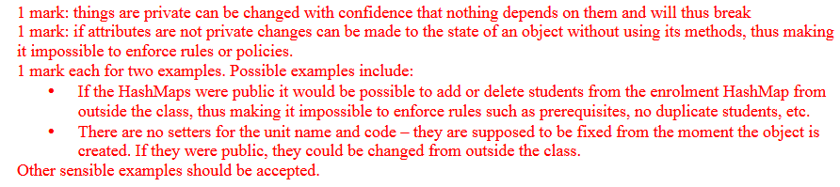

# Risks of repeated code

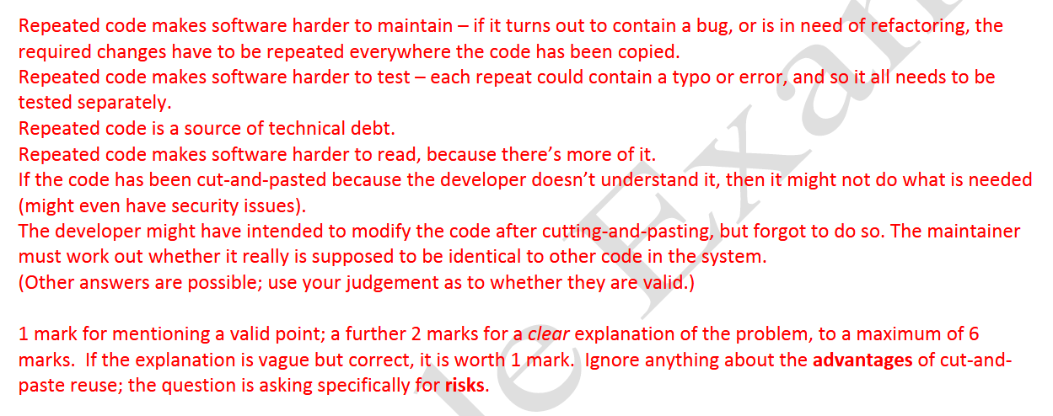

# Fixing repeated code

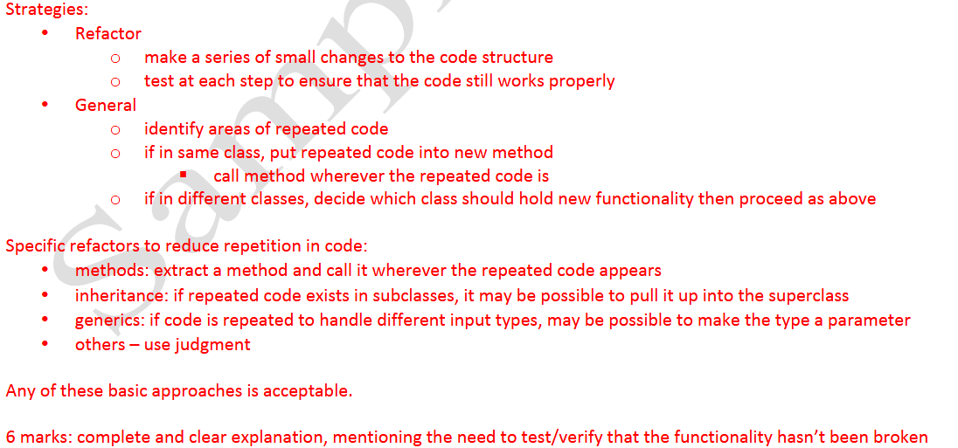

# JavaDocs for private attributes

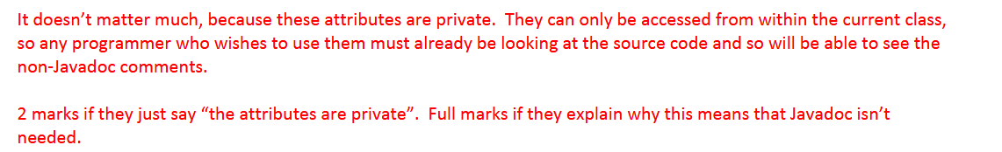

# Declared Exceptions vs Undeclared Exceptions

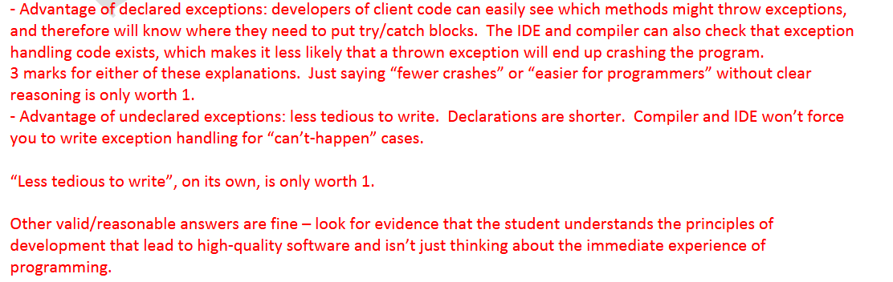

# Writing Executable Preconditions with Assertions and Exceptions

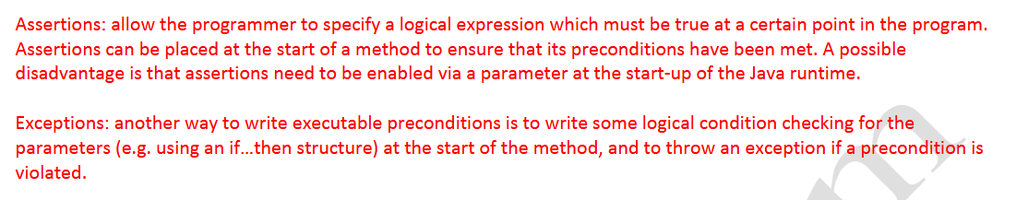

# Why not to cope with violated preconditions

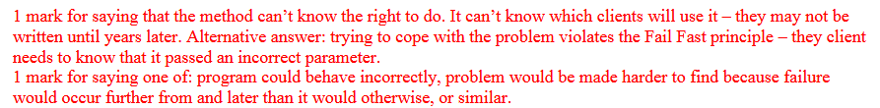

# Access control for methods in preconditions



# Benefits of Writing Preconditions before Implementation

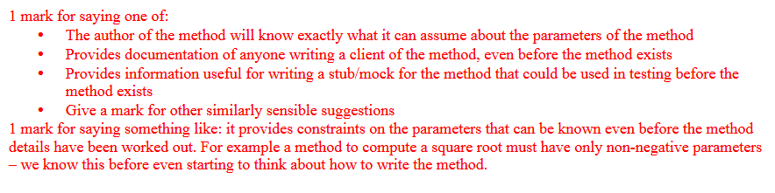

# Benefits of Writing Postconditions Before Implementation

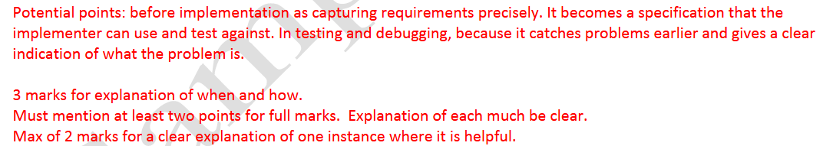

# Command-Query Separation, Relation to Design by Contract

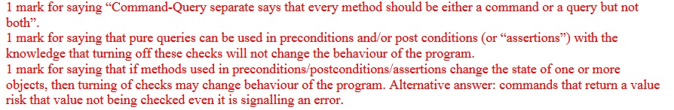

# Liskov Substitution Principle and Pre/Post Conditions



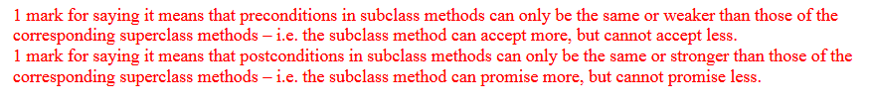

# Interface in Java

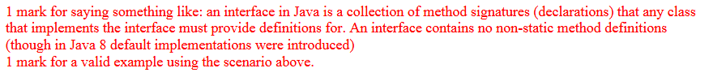

# Abstract Class in Java

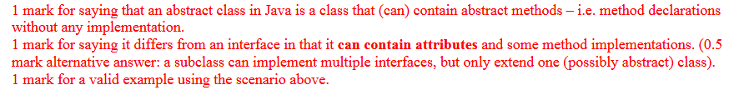

# Interfaces vs Abstract Classes

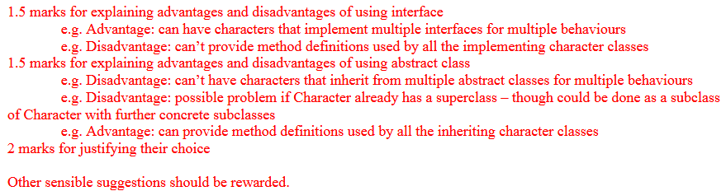

# Why Reduce Dependencies



# Encapsulation and Access Modifiers to control dependencies

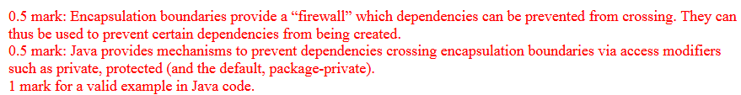

# What is good abstraction? Abstraction vs Abstract Classes

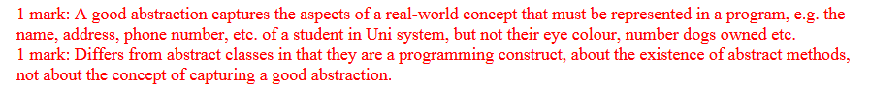

# More Specific Stuff

# Class Diagram and Sequence Diagram Mark Schemes

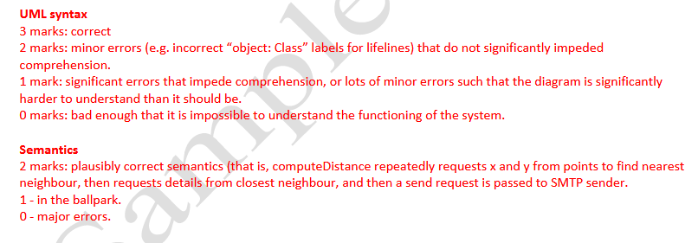

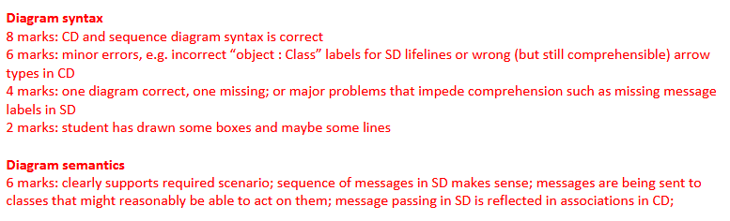

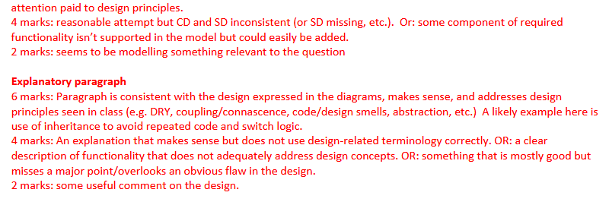

**Ease of Extending a System**

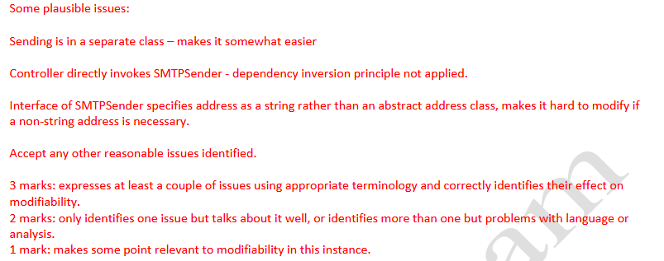

**Code Smells**

